Now, the perform statement is what is used to perform a sub-routine. And all I need to do in its simplest form is say perform and then create a subroutine name. You just make one up that represents the type of function we want to do.

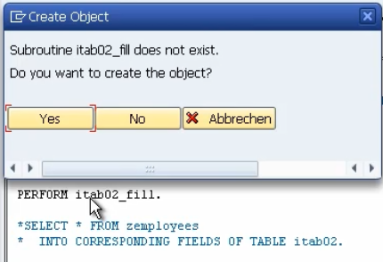

Now, of course all we've done is type in the code, we haven't created it yet, so we'll use forward navigation. So, I will double click. And it says the sub-routine does not exist, do you want to create it?

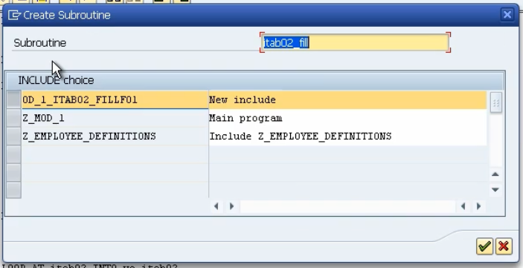And then it gives us an option of saying, well where do you want to create it? Now, we have the option of, we could include it in the include that we created but, you know, the include, maybe we just want to keep that for data definition. So, we won't choose that one. He gives us the choice of creating a brand new include. And it's given it its own name which we can change. But I don't want to do that. All I want to do is create this include in the main body of our program. So, I'm going to choose this one.

And then what the system does, it scrolls right to the bottom of the screen and creates a form. It gives us some comments here.

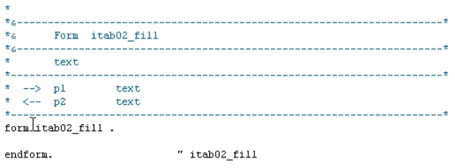

Then it allows us to enter whatever code we want, inside the form.

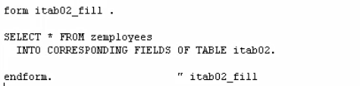

This code now belongs in its own sub rooting that we've included at the bottom of our program.

So, the system will perform any code we put inside the form endform structure, and then once the system encounters the endform statement processing will be returned to the next statement under our original perform statement.